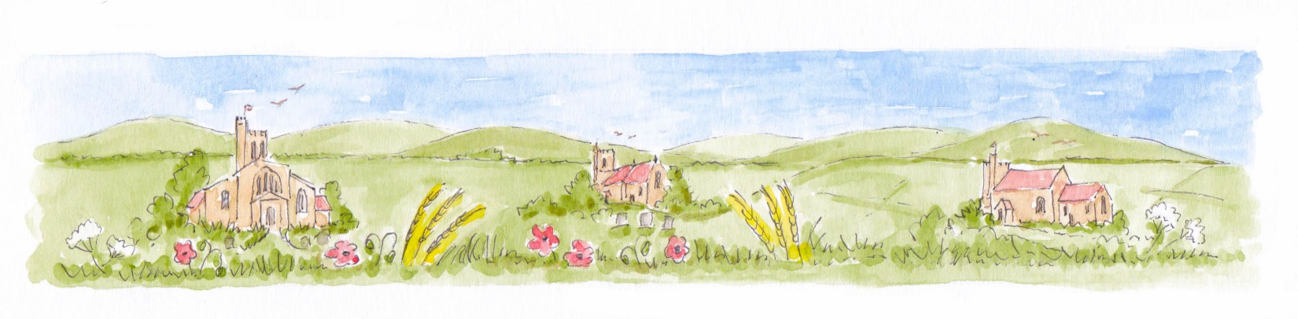
Family Worship at Home
You may want to light a candle

Prayers to say Thank You
Take turns to say something you’d like to thank God for. Each time, someone else says “Thank you” to Jesus for that thing.

Prayers to say Sorry
Put your hands on your head and think of something you’ve said or thought that you want to say sorry for.
Everyone says: Lord Have Mercy

Put your hands out in front of you and think of something you’ve done that you want to say sorry for.
Everyone says: Christ Have Mercy

Put your hands behind your back and think of something you’ve NOT done that you want to say sorry for.
Everyone says: Lord Have Mercy

Put your hands on your heart and someone says this prayer of forgiveness:
Almighty God,
who forgives all who truly repent,
have mercy upon us,
pardon and deliver us from all our sins,
confirm and strengthen us in all goodness,
and keep us in life eternal,
through Jesus Christ our Lord.
Amen

Reading from the Bible
Matthew details 6 miracles of Jesus in Chapter 8, and the first part of Chapter 9, of his Gospel. Read one of these miracles each time, or maybe act it out!
Verse 1 = Healing leprosy
Verse 5 = Healing the Centurion’s servant
Verse 14 = Healings in Peter’s house
Verse 23 = Calming a storm
Verse 28 = Sending away demons
Chapter 9, Verse 2 = Healing paralysis

After the reading, discuss these questions:
- What would it have been like to be with Jesus when this happened?
- How does this story make you feel?
- What could God be saying to us through this story?

Prayers for Help
Someone says this promise from the Bible:
Be still and know that I am God.

Stand up as still as you can; Take some deep breaths; Listen to your breathing; In your heads say “Hello” to the Holy Spirit; Think of something you need help with; Think of someone else who needs help; Then say the Lord’s Prayer together:
Our Father, who art in heaven,
hallowed be thy name;
thy kingdom come; thy will be done;
on earth as it is in heaven.
Give us this day our daily bread.
And forgive us our trespasses,
as we forgive those who trespass against us.
And lead us not into temptation;
but deliver us from evil. For thine is the kingdom…
For thine is the kingdom,
the power and the glory,
for ever and ever.
Amen

Blessing
Eat a treat! Then say together:
The Lord bless us and keep us.
Amen

Put out your candle if you lit one

