Morning Prayer on Sunday
O Lord, open our lips
And our mouth shall proclaim your praise.
A suitable hymn/song may be sung
The night has passed, and the day lies open before us;
let us pray with one heart and mind.
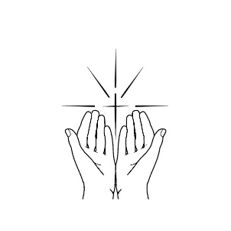
As we rejoice in the gift of this new day,
so may the light of your presence, O God,
set our hearts on fire with love for you;
now and for ever.
Amen.
Prayers of Penitence
We have not always worshipped God, our creator.
Lord, have mercy.
Lord, have mercy.
We have not always followed Christ, our Saviour.
Christ, have mercy.
Christ, have mercy.
We have not always trusted in the Spirit, our guide.
Lord, have mercy.
Lord, have mercy.

Psalm: The appointed psalm or the following may be said.

Psalm 121
I lift up my eyes to the hills; •
from where is my help to come?
My help comes from the Lord, •
the maker of heaven and earth.
He will not suffer your foot to stumble; •
he who watches over you will not sleep.
Behold, he who keeps watch over Israel •
shall neither slumber nor sleep.
The Lord himself watches over you; •
the Lord is your shade at your right hand,
So that the sun shall not strike you by day, •
neither the moon by night.
The Lord shall keep you from all evil; •
it is he who shall keep your soul.
The Lord shall keep watch over your going out
and your coming in, •
from this time forth for evermore.
Glory to the Father and to the Son
and to the Holy Spirit;
as it was in the beginning is now
and shall be for ever. Amen.

Scripture Reading(s)
These reading(s) or the appointed reading may be read:
‘Come to me, all you that are weary and are carrying heavy burdens, and I will give you rest. Take my yoke upon you, and learn from me; for I am gentle and humble in heart, and you will find rest for your souls. For my yoke is easy, and my burden is light.’ Matthew 11:28-30:
‘For God so loved the world that he gave his only Son, so that everyone who believes in him may not perish but may have eternal life.
‘Indeed, God did not send the Son into the world to condemn the world, but in order that the world might be saved through him. John 3:16-17
Listen! I am standing at the door, knocking; if you hear my voice and open the door, I will come in to you and eat with you, and you with me. Revelation 3:20:
The Apostles’ Creed
I believe in God, the Father almighty,
creator of heaven and earth.
I believe in Jesus Christ, his only Son, our Lord,
who was conceived by the Holy Spirit,
born of the Virgin Mary,
suffered under Pontius Pilate,
was crucified, died, and was buried;
he descended to the dead.
On the third day he rose again;
he ascended into heaven,
he is seated at the right hand of the Father,
and he will come to judge the living and the dead.
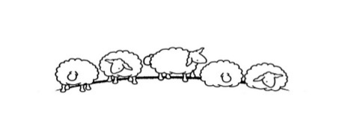
I believe in the Holy Spirit,
the holy catholic Church,
the communion of saints,
the forgiveness of sins,
the resurrection of the body,
and the life everlasting.
Amen.
Intercessions may be offered for:
- For those sick with COVID-19
- For the medical teams treating the ill
- For those isolated at home
- For those suffering financial hardship
- For the bereaved and those grieving
The Collect of the day or the following is said:
God of glory, by the raising of your Son you have broken the chains of death and hell: fill your Church with faith and hope; for a new day has dawned and the way to life stands open in our Saviour Jesus Christ.
Amen.
Let us pray with confidence as our Saviour has taught us
Our Father, who art in heaven,
hallowed be thy name;
thy kingdom come;
thy will be done;
on earth as it is in heaven.
Give us this day our daily bread.
And forgive us our trespasses,
as we forgive those who trespass against us.
And lead us not into temptation;
but deliver us from evil.
For thine is the kingdom,
the power and the glory,
for ever and ever. Amen.

A suitable hymn/song may be sung

The Lord bless us, and preserve us from all evil,
and keep us in eternal life.
Amen.
Let us bless the Lord.
Thanks be to God.

Please don’t leave this sheet in church after you’ve used it.
Take it home to use again or recycle
© The Archbishops' Council 2005

